Form A_03

Description of the Research Proposal for the PSI-FELLOW-II-3i application

Proposal ID-No.:

The research proposal is a description of the research project and it is essential to carefully read the document “Guidelines of applicants” (Form A-06) before continuing with your research proposal. It is important to keep in mind the format of the Research Proposal and to be familiar with the selection criteria that will form the basis for reviewers to evaluate the scientific merit of your research proposal.

Please follow the following layout for the preparation of the research proposal. Boxes should be expanded as needed. The maximum length of the research proposal is five (5) A4 pages. It is recommended to use the font type Verdana with font size 10.

Title:

Abstract: Write a short abstract that summarizes the goals and anticipated outcomes (250 words; 0.5 pages).

Project Description: Develop a work plan in which research objectives, milestones and tasks, suitable experimental approaches are described. Include as well a feasibility analysis (2 pages).

References: Include minimum 7 and maximum 10 literature citations that is considered to be key literature references for your research project (0.5 pages).

Supervisor’s Addendum: provide a short description how the applicant will be supported and which resources will be attributed to the project. (0.5 pages).

Project Management table: Prepare an overview table that schedules the milestones and main tasks along a timeline of 24 months. It is important to identify at least 3 milestones and 2 tasks per milestone. The table below has 6 project time periods (e.g., 0-4 months is one such interval) and your project should be presented with a similar time planning, not more than 6 and not less than 4 time intervals (i.e., 0-6, 7-12, 13-18 and 19-24 months).

Use as well color coding to show that the progression of the science over time (that is, Milestone 1 and Milestone 3 is not reached at the same time and that achievement of Milestone 3 is dependent on reaching Milestone 1).

An example of such a Table is given below. The font size can be Verdana 8.

Goal of project:
 | Project month
 | 0-4 | 5-8 | 9-12 | 13-16 | 17-20 | 21-24
Milestone 1

Task 1
Task 2 (- Task X)
Milestone 2

Task 1
Task 2 (- Task X)
Milestone 3
(- Milestone X)

Task 1
Task 2 (- Task X)

One pager Project Overview: Prepare a one-page document (could be a Powerpoint slide) with sections: Aim, Outcome and Future Perspective to summarize your project. Include as well a picture, diagram, photo, etc. that could serve as visual representation of your research project proposal. Maximum 60 words are allowed for the sections areas below “Name” and “Title”.
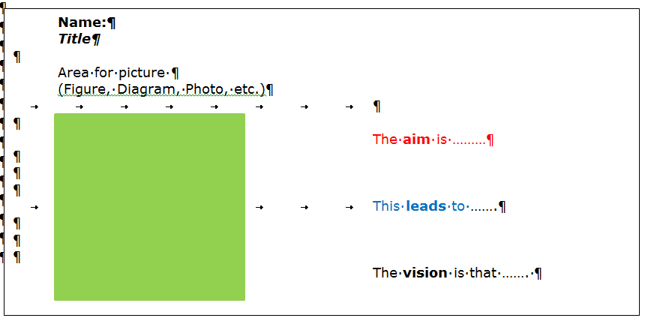

https://www.psi.ch/psi-fellow/list-of-principle-investigators-and-themes

