CATCOS Aerosol Instruments SOP

Document version 1.5 for El Tololo Chile
Nicolas Bukowiecki, Günther Wehrle, April 29 2013

Contacts
http://www.psi.ch/catcos

Log File
Enter the results of all checks also into the electronic logbook:
Press <Return> twice in the blue monitor window to open the online log. You can also paste text into the log by pressing the middle mouse button.
Please report:
- Date and time of checks, name of operator
- Any exceptional test results and observations checks (write ok if everything is fine)
- Flow readings from weekly flow checks

Regular checks (at every visit)
Inlet and rack:
- Important: Is the drain bottle tightly closed? This is important to ensure that no laboratory air is leaking into the instruments.
- Is the UPS working correctly? If there is just the red light on or no light at all, this is indicating that the UPS is not working.

Instruments:
- Aethalometer: Check display for error messages and status (Green LED means ok, green blinking means automatic tape advance is ongoing)
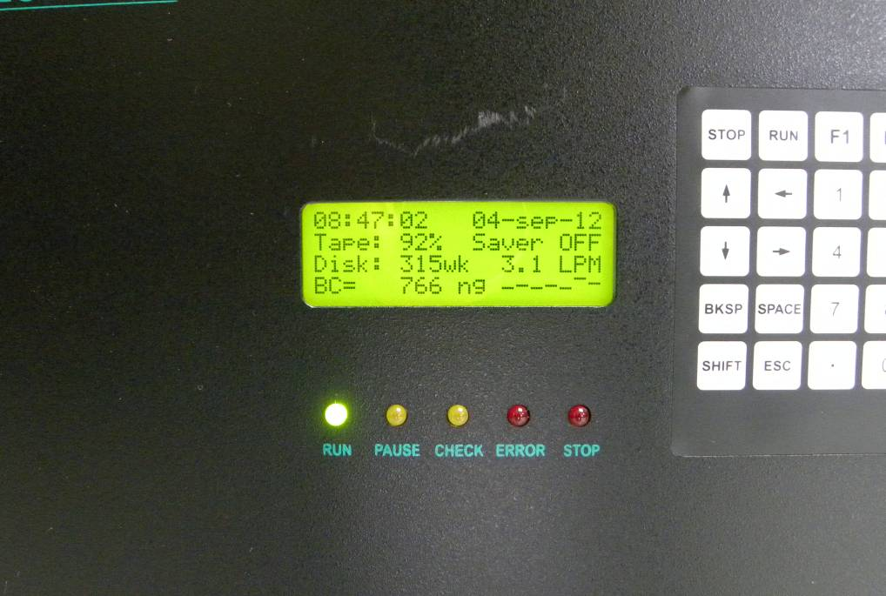

- Nephelometer: Check display for error messages and status
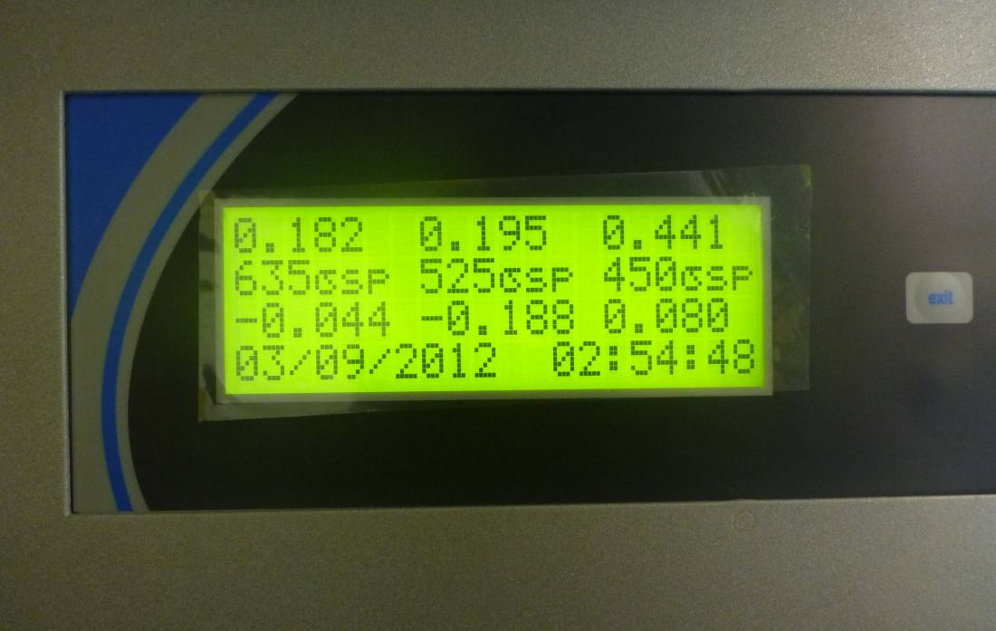
Computer:
- In the blue data acquisition window: Are the letters “BCGN” all present in the status line in the bottom left corner? If not reboot the computer.
- Check the values in the window: Are all values in the indicated range and actualized as they should?

 | Actualization interval | Range
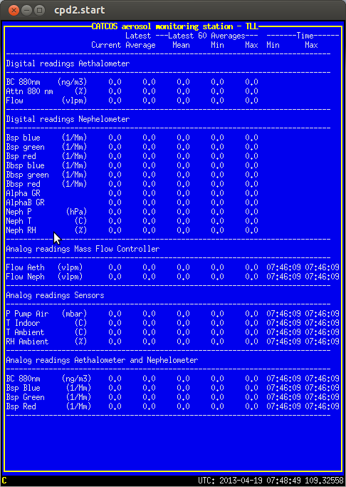 | Aethalometer: Every 5 minutes | BC 880 nm: Normal range is between 0 – approx. 5000 ng/m³. In case of very clear atmosphere noise (including negative values) around zero may occur.
 | Nephelometer: Every minute or faster | Values should be in the range 0 – 500 mM⁻¹.  Normally: Blue > Green > Red  During autozeroing (every 36 hours) the values are zero.
 | Flows: Every second | Values are normally constant (Aethalometer 3.7/ Nephelometer 4.1 lpm).
 | RH, Temperature and Pressures: Every second | Do the values make sense?  P pump < 700 mbar? If not: Pump maintenance needed.  In case of highly unrealistic values check sensor fuses.
 | Analog readings from Aethalometer and Nephelometer: Every second | Value fluctuation is normal.  Values should fluctuate around the digital readings.

Graph window:
- To update the window click ‘replot’. Are there any unusual features in the data (besides the nephelometer autozeroing)? Note: Due to a software bug it may occur that there are gaps in the data which are not real. You can always close the graph window and reopen it (CPX2).

Every 1-2 weeks
- Check aethalometer filter tape: Replace if nearly full (instructions see appendix to this document). Are the collected spots round, well defined and surrounded by clean filter tape? Are there any tape jams? Does the filter tape still look smooth after passing the sampling head?
- In-line Flow checks with bubble flow meter.
Please make a flow measurement every two weeks. The flow measurement of the Aethalometer is very important because it affects the calculation of the BC (black carbon) concentration.
Three flows should be measured, the “Total flow”, the ”Aethalometer flow” and the “Nephelometer flow”.
The “Total flow” of the inlet is measured before the “Water trap”, it should equal the sum of the two other flows.
The “Aeth flow” and the “Neph Flow” are measured after the “Water trap”.
The flows are regulated by the “Read-y” MassflowControllers (MFC) from Voegtlin .
The BubbleFlowMeter from Buck is measuring the volumetric flow. Make sure there is enough liquid soap in the flow meter to cover the bottom of the cylinder about 2 mm. Turn it on and connect the 230V power supply to the socket at the rack if the red “low battery” lamp is on. Connect the two black hoses to the flow meter, vacuum side on top, hose with ambient pressure below. Connect the device to the water trap. Produce a few bubbles by pressing the black nibble to humidify the walls. The flow meter is ready when you are able to guide a perfect shaped bubble up to the top of the transparent cylinder. Now you can do single measurements by pressing the “ON” button after each measurement. If you do several measurements without pressing the “ON” button, the average of the measurements is displayed. For example the value A5 followed by 3.773 means the average of the last five measurements is 3.773 liters/minute. If the value “EEEE” is displayed, the latest flow measurement had a disagreement from the average of more than 10% and you have to start all over again.
For the flow measurement you should at least measure an average of five values.
Make sure the Neph is in normal measuring mode, no “Zero-“ or “Span” calibration.
Please measure the three flows at the watertrap, the positions are labeled with a read tape.
The measurements should be about
7.8 l/min for the “Total flow”,
4.1 l/min for the “Neph. flow” and
3.7 l/min for the “Aeth. flow”.
At least the “Total flow” should be measured “Inline” with the two hoses of the “Buck” connected to the inlet and the watertrap to make sure that the tubing outside of the building is not clocked.
Please read the flow that is displayed at the green Aethalometer front panel.
Enter the values to the online-logbook by making a mouse click into the blue window of the data acquisition computer. Then press the “Enter” key two times. A window will pop up where you can type in for example
BubbleFlowMeasurement: Total 7.8l/min; Neph 4.1; Aeth. 3.7; Aeth.flow displayed 3.7; G.Wehrle
Pressing “Enter” another time will close the window and save your entry to the data.
Please read the pressure of the pump in the blue window, it should be at least 200mbar below ambient, that the MFCs are able to regulate. If the pump pressure is not low enough the pump membrane is probably broken and should be changed.
Then look at the flow that is displayed in the green front panel of the Aethalometer. It should differ not more than five percent from the flow measured with the Buck. Otherwise you should perform a flow calibration of the Aethalometer’s internal mass flow meter. The procedure is described in the Aeth. manual. It is a two point calibration at zero flow and another flow that is compared with the Buck flow. Since the former internal pump is removed from the Aethalometer you have to disconnect the external pump manually during the zero flow calibration by closing the valve at the Aeth MFC.
When you are finish with the flow measurement you can leave the soap water in the Buck but please close the inlets that the soap can not dry out and get sticky.
Make sure the inlet plug and all other connections are reconnected to the watertrap and the black hose is not warn out or has little leaks.

Aethalometer and nephelometer:
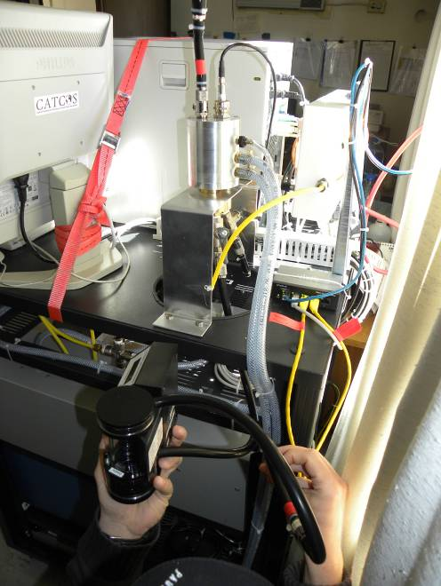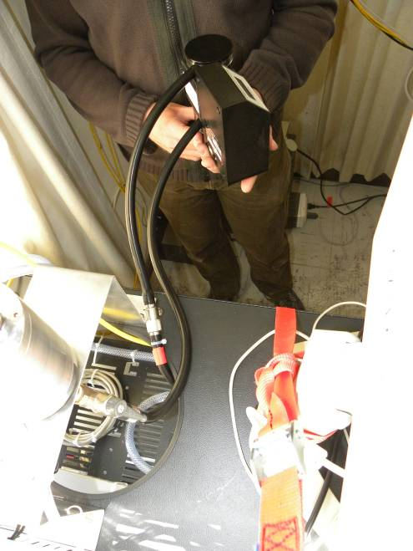

Inlet air:
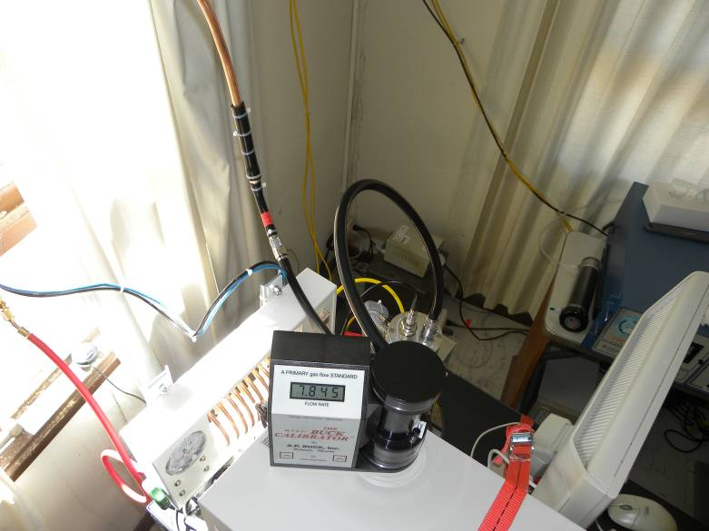
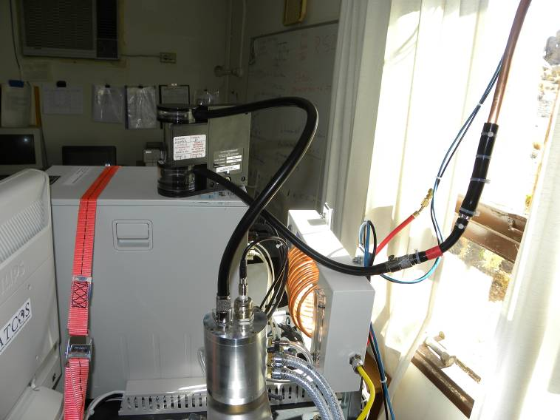

- Nephelometer: Span check

Summary:
- Open the CO2 bottle on the main valve
- Regulate the flow to approx. 4 lpm (rotameter).
- On the neph press, ‘Enter’, select ‘Calibration’, select ‘Span Chk’. The span check starts automatically and will last 30-60 minutes.
- If the CO2 flow in the rotameter drops to zero and there are again non-zero values for the nephelometer in the blue monitor window, then the calibration has finished
- Close the CO2 bottle (main valve)-

Make an entry to the logbook like “Start of Neph full calibration; G.Wehrle”
Open the main valve of the CO2 gas bottle. Check the bottle pressure to see if it will soon be empty.
Adjust the pressure reducer to have about 1 bar overpressure. Make sure all other valves in the CO2 line are open.
Press the buttons at the Neph and select the menu calibration. Select the do full calibration and press enter. After 30 seconds the Neph should start flushing with CO2. Adjust the needle valve at the rotameter to a flow of about 4l/min.
When the Neph is finish with the span calibration it will close automatically the CO2 line and the ball in the rotameter that indicated the 4l/min will fall down to zero. This will be after about 30 minutes. You can now close the main valve of the CO2 bottle while the Neph is automatically doing the zero adjustment.
When the Neph is finish with the zero adjustment it will automatically go back to normal mode, at the front panel of the Neph the word “stability“ is no longer flashing.
Please make an entry to the logbook like “End of Neph full calibration; G.Wehrle” and make ones again sure the main valve of the CO2 bottle is closed.

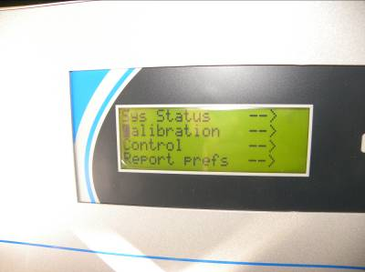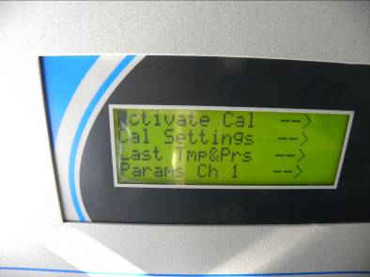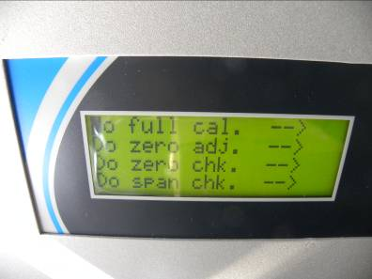
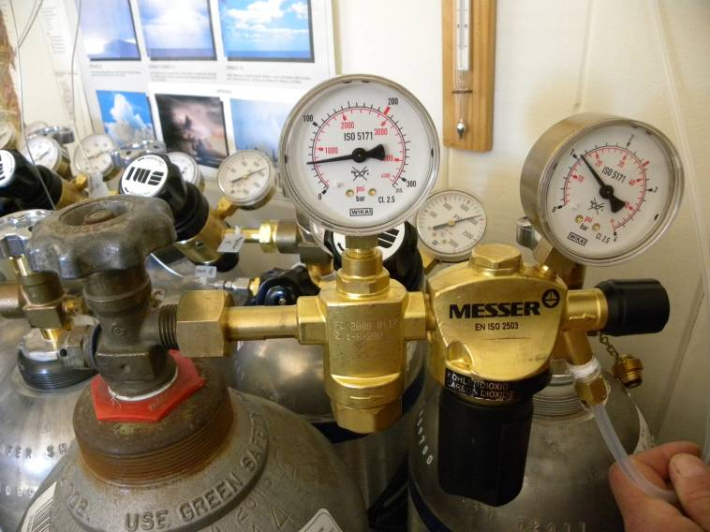

- Leak test:
Don’t make a Neph. CO2 calibration during the leak check periode.
Make an entry in the online logbook like “Start of zero filter leak check; G. Wehrle”
Disconnect the inlet tubing from the watertrap and connect the white HEPA filter instead.
Watch the Neph. and Aeth. signals in the data acquisition software. When they came down continue the measurement for at least one hour.
If the instruments do not measure around zero, check all hoses and connections for leaks. To find the leak it can also be helpful to connect the HEPA filter at other positions or directly in front of the instruments.
Reconnect the inlet and check the short piece of black tubing between the connector and copper tubing visually for cracks.
Make an entry to the logbook that the zero check is finish and the instruments are back to normal measurement mode like
“End of zero filter leak check; G. Wehrle”.

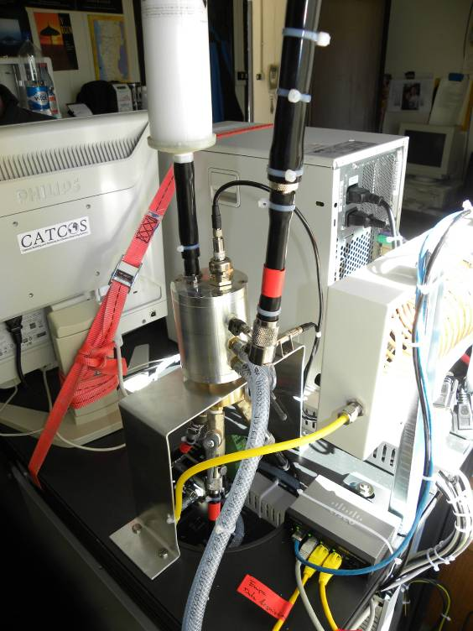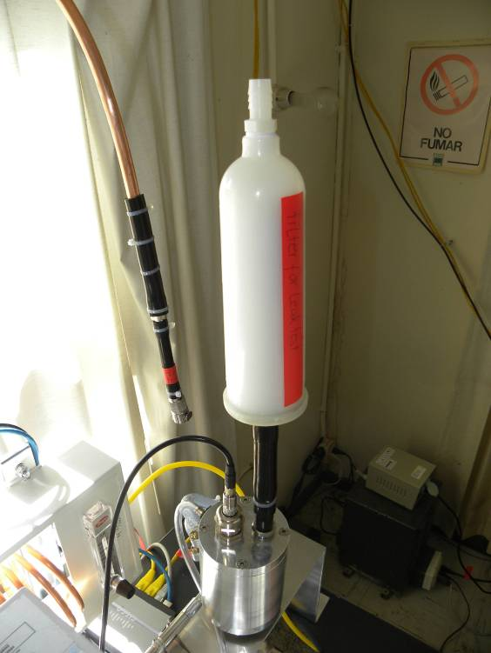

Monthly
- Is all black tubing looking intact and connected?
- Is everything firmly attached?
- Is the insect mesh clean (not too many insects)? Remove insects and debris if necessary.
- Is there any water from the water trap in the drain bottle? If there is any water remove it regularly. Do not exceed the maximum.

Every three months
- Nephelometer full calibration with CO2 (see manual)

Longer intervals
- Yearly: Check filters if visually dirty and replace if necessary (mass flow controllers, CO2)
- Yearly: Check runtime of UPS (UPS menu ‘Measurements’ , toggle the entries) and replace battery if the runtime is less than 10 minutes
- Important: Also refer to the aethalometer and nephelometer user manuals for long term-checks.

Appendix
Install new roll of aethalometer tape:

Summary;
- Remove spool screws and the transparent round plates
- Remove cover screws to see optical head
- Remove tape debris if dirty
- Cut old tape left of the optical head
- Press and hold “Tape advance” button and pull the filter tape out of the optical head when it is lifted up and the white transportation wheels are in the position to allow pulling the filter through without the use of any force. Probably you have to repeat this a few times to get the filter tape out.
- Remove supply roll
- Remove takeup roll
- Install new roll on the supply side. Therefore push away the black metal spring.(Avoid to touch the tape where later the filter spots will be measured)
- Lift up the optical head by pressing and holding “Tape advance” button.
- Push tape through the head
- Press button again and pull tape through the transportation wheels about 10 cm.
- Clip tape to empty hub with some tape.
- Install takeup hub and wind it up about two times
- Install the transparent round plates
- Install cover of optical head
- Check that all four screws are finger tide
- Press and hold the tape tension button until the takeup roll stops winding up the tape
- Then go to the front panel, press the ESC button two times and enter the security code (111) followed by the ENTER
- Press the arrow down key to get to the “Install new tape” menu.
- Press ENTER and give in the security code again.
- Answer the “Is the tape properly replaced” question with YES (ENTER)
- The display shows now “Operate”, press ENTER
- Press ENTER again to go to the “Auto. Mode”
- Measurement will start after about 15 minutes, on the display you should see “Tape 99%” and actual concentrations.
In detail:
Due, to a really bad Aeth. software the filter change is not working like it is described in the manual.
Make an entry to the logbook like “Start of Aeth. filter change; G.Wehrle”
Open the front door of the Aeth. and find the switch for “tape advance” and “tape tension”.
Unscrew and remove the cover of the optical head. Stop the air flow by closing the valve behind the Aeth. MFC and unscrew and remove the two transparent round plates in front of the filter coils.
Cut the filter tape and press the “tape advance” button until the optical head is lifted up and stays open. Pull gently at the filter and remove it from the filter head and the transportation wheels when it is released.
Remove the two coils and insert a new filter on the left hand side and an empty coil on the right. Press again the “tape advance” button and feed the filter through the optical head and transportation wheels when they are open. Pull it about 30 cm in the direction of the empty coil. You might press the “tape advance” button more than once to do so.
Tape the filter to the empty coil and wind it up about three turns. Make sure the filter is going around the lever for the end switch that stops the tape tension motor. Place the two round transparent plates back in their position in close the thumb screws finger tight. Press the “tape tension” button until the right coil stops turning.
Make sure the filter tape is not damaged and remove any dust inside the instrument. Put the cover of the optical head back in its position. Turn the instrument off and on and close the front door.
Open the valve behind the Aeth. MFC.
Make an entry to the logbook like “End of Aeth. filter change; G.Wehrle”
After about 15 minutes the Aethalometer is in normal measuring mode and should display the first BC (black carbon) concentrations and the flow.
When the last filter is inserted order some new.

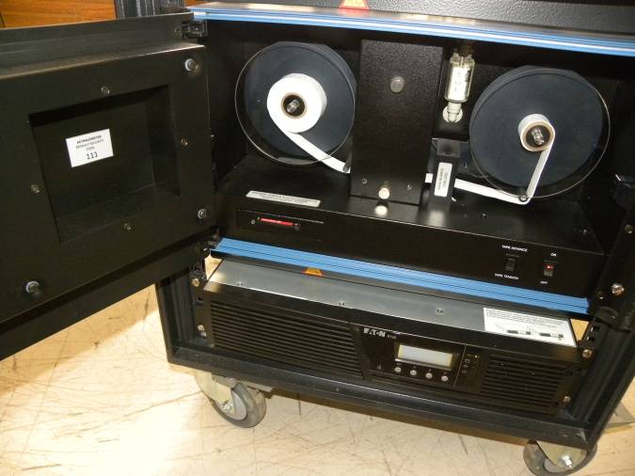

Other
If you connect a new instrument to the unused inlet plug, please make sure the flow is monitored and logged in regular intervals.

Reformat the flash card in the instrument when Aethalometer displays the error "Disk problem". Use the accessory flash card reader. Reformat as FAT32.

