CATCOS Aerosol Instruments SOP

Document version 1.3
Nicolas Bukowiecki, Günther Wehrle, Oct 4, 2012

Contacts
http://www.psi.ch/lac/catcos-operations

Log File
Enter the results of all checks also into the electronic logbook:
Press <Return> twice in the blue monitor window to open the online log. You can also paste text into the log by pressing the middle mouse button.
Please report:
- Date and time of checks, name of operator
- Any exceptional test results and observations checks (write ok if everything is fine)
- Flow readings from weekly flow checks

Daily checks
Inlet (outside)
- Is everything firmly attached (GPS, sensors and inlet cover)?
- Is the insect mesh clean (not too many insects)? Remove insects and debris if necessary.
In the lab
Inlet and rack:
- Is there any water from the water trap in the drain bottle? If there is any water remove it regularly. Do not exceed the maximum.
- Is there no water leaking into the laboratory from the roof?
- Important: Is the drain bottle tightly closed? This is important to ensure that no laboratory air is leaking into the instruments.
- Is the UPS working correctly? If there is just the red light on or no light at all, this is indicating that the UPS is not working.

Instruments:
- Aethalometer: Check display for error messages and status (Green LED means ok, green blinking means automatic tape advance is ongoing)
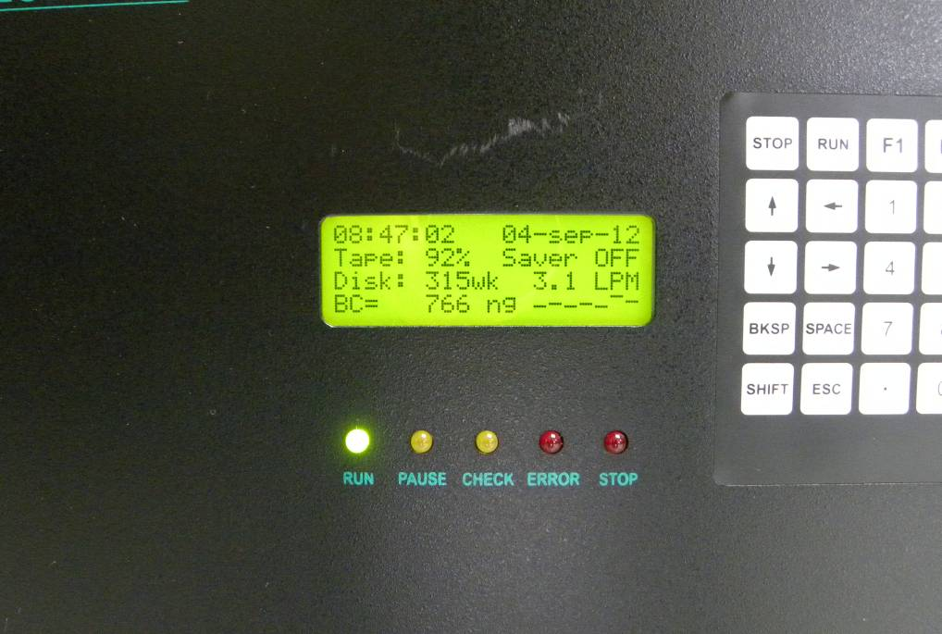

- Nephelometer: Check display for error messages and status
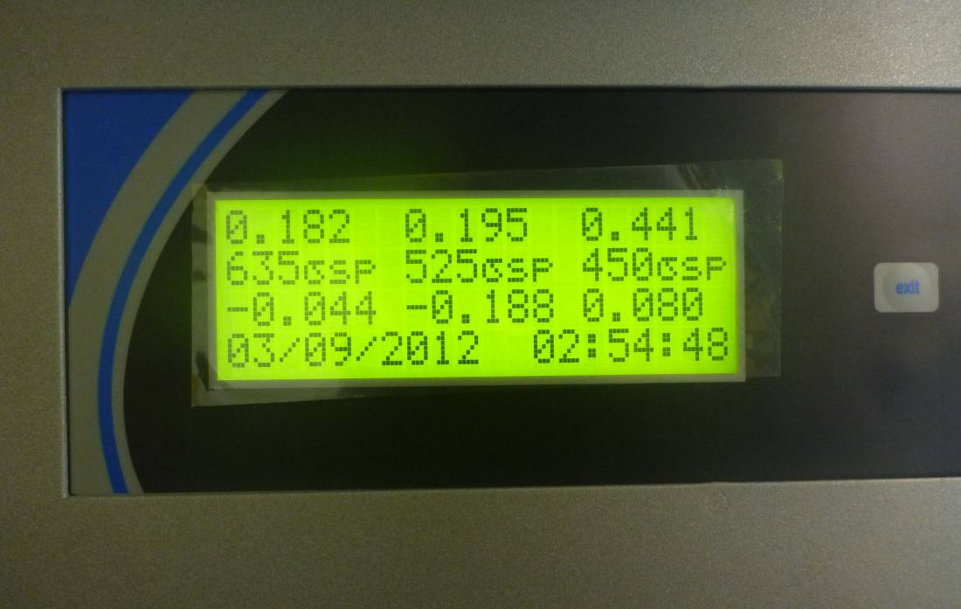
Computer:
- In the blue data acquisition window: Are the letters “BCGN” all present in the status line in the bottom left corner? If not reboot the computer.
- Check the values in the window: Are all values in the indicated range and actualized as they should?

 | Actualization interval | Range
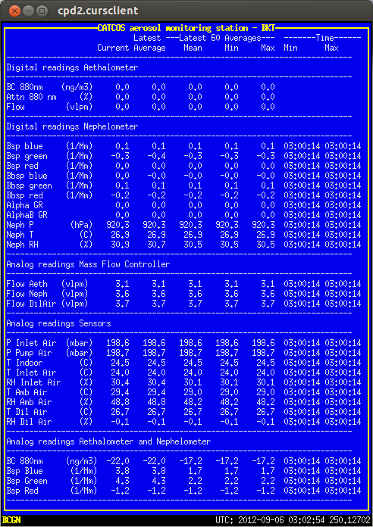 | Aethalometer: Every 5 minutes | BC 880 nm: Normal range is between 0 – approx. 5000 ng/m³. In case of very clear atmosphere noise (including negative values) around zero may occur.
 | Nephelometer: Every minute or faster | Values should be in the range 0 – 500 mM⁻¹.  Normally: Blue > Green > Red  During autozeroing (every 36 hours) the values are zero.
 | Flows: Every second | Values are normally constant (Aethalometer 3.1/ Nephelometer 3.6 lpm, dilution Air 3.7 lpm). If dilution air is zero: Check compressor operation (power, pressure)
 | RH, Temperature and Pressures: Every second | Do the values make sense?  RH dilution air < 5% If not: Compressor maintenance needed  P pump < 700 mbar? If not: Pump maintenance needed.  In case of highly unrealistic values check sensor fuses.
 | Analog readings from Aethalometer and Nephelometer: Every second | Value fluctuation is normal.  Values should fluctuate around the digital readings.

Graph window:
- To update the window click ‘replot’. Are there any unusual features in the data (besides the nephelometer autozeroing)? Note: Due to a software bug it may occur that there are gaps in the data which are not real. You can always close the graph window and reopen it (CPX2).
Weekly
- Check aethalometer filter tape: Replace if nearly full (instructions see manual). Are the collected spots round, well defined and surrounded by clean filter tape? Are there any tape jams? Does the filter tape still look smooth after passing the sampling head?
In-line Flow checks with bubble flow meter. Avoid soap liquid to get into the instruments.
Are the measured values consistent (+- 10 %) with the readings on the computer?
Aethalometer and nephelometer:
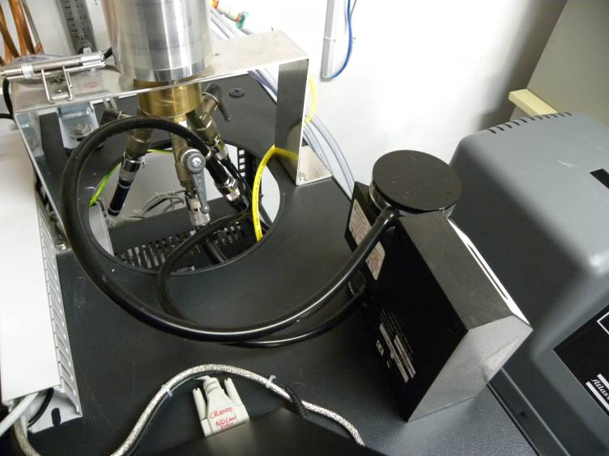
Inlet air:
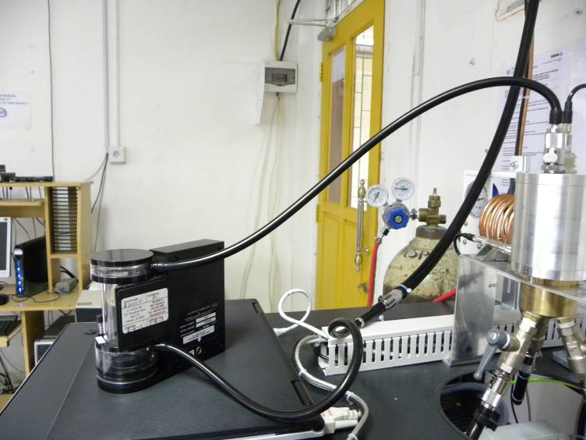

Dilution air:
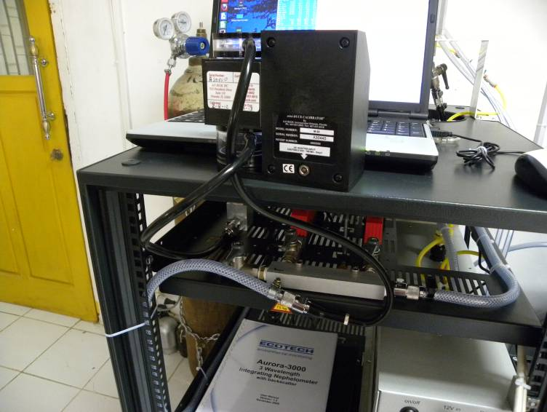

- Nephelometer: Span check
- Open the CO2 bottle on the main valve
- Regulate the flow to approx. 4 lpm (rotameter).
- On the neph press, ‘Enter’, select ‘Calibration’, select ‘Span Chk’. The span check starts automatically and will last 30-60 minutes.
- If the CO2 flow in the rotameter drops to zero and there are again non-zero values for the nephelometer in the blue monitor window, then the calibration has finished
- Close the CO2 bottle (main valve)-

- Leak test: Instructions and tools will follow

Monthly
- Is all black tubing looking intact and connected?
- Drain water from the compressor pressure tank

Every three months
- Nephelometer full calibration with CO2 (see manual)

Longer intervals
- Yearly: Check filters if visually dirty and replace if necessary (mass flow controllers, CO2)
- Yearly: Check runtime of UPS (UPS menu ‘Measurements’ , toggle the entries) and replace battery if the runtime is less than 10 minutes
- Important: Also refer to the aethalometer and nephelometer user manuals for long term-checks.

Appendix
Install new roll of aethalometer tape:
- Remove spool screws and the transparent round plates
- Remove cover screws to see optical head
- Remove tape debris if dirty
- Cut old tape left of the optical head
- Press and hold “Tape advance” button and pull the filter tape out of the optical head when it is lifted up and the white transportation wheels are in the position to allow pulling the filter through without the use of any force. Probably you have to repeat this a few times to get the filter tape out.
- Remove supply roll
- Remove takeup roll
- Install new roll on the supply side. Therefore push away the black metal spring.(Avoid to touch the tape where later the filter spots will be measured)
- Lift up the optical head by pressing and holding “Tape advance” button.
- Push tape through the head
- Press button again and pull tape through the transportation wheels about 10 cm.
- Clip tape to empty hub with some tape.
- Install takeup hub and wind it up about two times
- Install the transparent round plates
- Install cover of optical head
- Check that all four screws are finger tide
- Press and hold the tape tension button until the takeup roll stops winding up the tape
- Then go to the front panel, press the ESC button two times and enter the security code (111) followed by the ENTER
- Press the arrow down key to get to the “Install new tape” menu.
- Press ENTER and give in the security code again.
- Answer the “Is the tape properly replaced” question with YES (ENTER)
- The display shows now “Operate”, press ENTER
- Press ENTER again to go to the “Auto. Mode”
- Measurement will start after about 15 minutes, on the display you should see “Tape 99%” and actual concentrations.

Other
If you connect a new instrument to the unused inlet plug, please make sure the flow is monitored and logged in regular intervals.

