Convection driven droplet detachment from gas diffusion layers

A. Mularczyk¹, A. Lamibrac¹, F. Marone², F. N. Büchi¹, T. J. Schmidt^{1,2}, J. Eller¹
¹ Electrochemistry Laboratory, Paul Scherrer Institute Villigen, Switzerland.
² Swiss Light Source, Villigen, Switzerland
³ Laboratory of Physical Chemistry, ETH Zürich, Zürich, Switzerland.
adrian.mularczyk@psi.ch

Droplet formation in the cathode gas flow channel of polymer electrolyte fuel cells (PEFCs) can negatively impact the fuel cells performance due to increased pressure drops or even blockage of reactant gas. Using sub-second X-ray tomographic microscopy (XTM), the liquid water distribution in the gas diffusion layer (GDL) GDL and the flow channel was determined and the behaviour of droplet detachment at the GDL-gas channel interface monitored. The effect of water injection rate on the size and frequency of droplets was monitored using both, fast X-ray 2D radiography (3 ms exposure time) as well as computed tomography (0.75 s scan time, 2.55 s repeating frequency).
For the different water injection rates, the droplet formation was found to be very periodic with the droplet growth showing a repeating pattern. The droplet diameter evolution for two different injection rates is shown in Figure 1 (a). For the case of 1000 nL/min water injection, the droplets were smaller and retained a circular shape almost until detachment, while the droplets formed at an injection rate of 350 nL/min grew larger and evolved into a tear shape after a certain droplet size. For both conditions, the gas flow induced deformation started at a droplet volume of about 9 nL. Above this point, an estimate of the water volume is made using a linear extrapolation of the initial growth rate that is extended to the point in time where droplet detachment was observed. The final droplet volume was estimated to be 17.6 nL at an injection rate of 350 nL/min and 10.3 nL at 1000 nL/min.
Figure 1 (a) and (b) compares the water volume inside the GDL calculated for every 3 μm thick through-plane layer of the discrete voxel based domain. Water volume in the GDL near the inlet was found to be high and decreasing towards the gas channel, corresponding to a high saturation near the inlet and a low saturation near the gas channel. It was found that no changes occurred in the bulk of the GDL when changing the injection rate from 350 to 1000 nL/min. At an injection rate of 350 nL/min, a strong deviation of water volume between scans can be observed in the upper layers of the GDL.
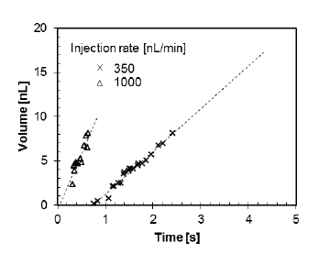  a | 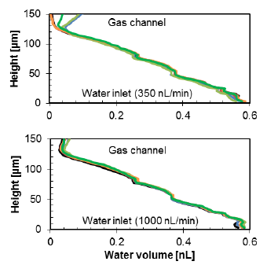  b  c
Figure 1: (a) Droplet volume calculated from observed diameters for injection rates of 350 and 1000 nL per minute. Water volume over the height of the GDL domain, for an injection rate of 350 nL/min (b) and 1000 nL/min (c).

References:
1. A. Lamibrac, J. Roth, M. Toulec, F. Marone, M. Stampanoni, F. N. Büchi., J. Electrochem. Soc. 163, 2016, 202-209

