

#### The 12th Meeting of the

**„European MELCOR and MACCS User Group“**

**Organized by NUBIKI - Nuclear Safety Research Institute, Hungary**

**In Support of the Cooperative Severe Accident Research Programme (CSARP) will be held in**

**Budapest, Hungary**

**4th – 8th May, 2020**

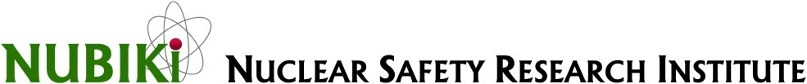

#### With special thanks to EMUG’s permanent stake holders:

**United States Nuclear Regulatory Commission (US NRC) Sandia National Laboratories (SNL)**

**Paul Scherrer Institute (PSI)**

********

**Announcement and Call for Presentations**

|  |  |
| --- | --- |
| Deadline for registration to the meeting  (including indication of presentation(s) title(s) and duration)  Advised hotel reservation **28st February 2020** | **20th March 2020** |
| Presentation(s) in PowerPoint or in PDF format | At the day of the meeting |

On-line information is available at

http://www.nubiki.hu/

**or**

http://www.psi.ch/emug/

# ORGANIZATION AND HOST

The 12th Meeting of the European MELCOR and MACCS User Group will be held on 4th to 8th May 2020.

The meeting will start on 4th May with a full-day MACCS workshop and on the next day continue with a full day of MACCS technical presentations.

On 6th May a full day will be devoted to MELCOR WS and another full day to MELCOR technical presentations.

On Friday May 8th a full day excursion to Paks is organized with the visit to the Maintenance and Training Center of Paks NPP.

Final details and a final draft agenda will be sent to registered participants before the meeting.

# BACKGROUND OF THE MEETING

The MELCOR and MACCS severe accident and consequence codes are developed by Sandia National Laboratories (SNL) for the U.S. Nuclear Regulatory Commission (NRC) in the USA, and are provided to various European organizations through bilateral agreements under the ‘Cooperative Severe Accident Research Program’ “CSARP” between US-NRC and the European organizations. The codes have been used for many reactor safety applications by these organizations. Some of these organizations also continuously assess the codes with data available from Severe Accident Research programs. A few organizations have also developed models for certain critical issues, which appear in local versions of MELCOR for testing and with the goal of implementation in future releases from SNL.

The main interests in establishing the user group are to foster experience and information exchanges among the European organizations through organized annual meetings and to establish common needs on further model and correctional development of MELCOR and MACCS. The first meeting of the EMUG hosted by PSI was held in December 2008. PSI is acting as coordinator of the group.

## AIMS OF EUROPEAN MELCOR and MACCS USER GROUP

* To provide a forum for the presentation and discussion of the experience gained by:
  + MELCOR assessment using integral and separate-effect tests leading to presentation of performance of models and related issues, including sensitivity to selected model parameters and model uncertainties.
  + Model development efforts.
  + Application of MELCOR for plant safety studies, including Level 2 PSA, which demonstrates strengths and weaknesses of MELCOR models in reproducing the individual severe accident phenomena, and interactions between them occurring in the nuclear part and balance of plant systems, and the effect of operator actions on the accident progression through user input as introduced in the code input models.
  + Application of MACCS for accident consequence calculations including Level 3 PSA
  + Use of codes with different compilers and operating systems.
* Prioritization of user error correction and model development needs, to be transmitted to the code developers and the US NRC.
* To minimize the efforts required to obtain an adequate knowledge of optimum use of MELCOR and MACCS, through sharing of experience.
* To support the gaining of MELCOR and MACCS knowledge and experience, particularly concerning the younger and less experienced users.

# SCOPE, CONTENT AND OUTLINE OF THE MEETING

The four day MELCOR / MACCS meeting is divided into two sections for each of MELCOR and MACCS:

## NRC and SNL Presentations

One day will be devoted to presentations from NRC/MELCOR developers and one day will be devoted to presentations from NRC/MACCS developlers. Each of the following four topics could be given by one presentation:

* NRC MELCOR Activities
  + Code applications
  + Code perspectives, possibility of distribution to international partners, status and future areas of CSARP program
  + New considerations of code development
* MELCOR input
  + New features of input conversion
  + New input capabilities in M2.1/2.2
* Current MELCOR development thrust areas
  + Quality assurance
    - * + Code assessment work and regression testing
        + Code distribution and issue management
  + New MELCOR Models – discussion of new modelling and experience using new models
  + Current code development
* Applications
  + MELCOR best practices
  + Guidance for plant applications

## User Presentations

One day will be devoted to presentations from all of the European organizations each for MELCOR and for MACCS. For those who would like to present their experience in plant applications of MELCOR 1.8.6 and MELCOR 2.1/2.2, the organizers of the meeting express their wish to see presentations not only on specific aspects of the plant applications evaluating safety aspects of the plants in interest but also the experience in use of the MELCOR models, input parameters, nodalization aspects which have certain bearing on the performance of the code, as well as the quality of the code estimates.

Presentations will be roughly grouped into the following 4 sessions for MELCOR:

Group 1: User experience with nodalization regarding simulation of different issues with preference to focus on RCS, core and RN inventory and release modeling.

Group 2: Modelling features (early and late phase core degradation, corium pool formation, lower head behavior, RN release, SFP, etc), new modelling efforts and nuclear fusion application.

Group 3: Model development and assessment, integral assessment, sensitivity studies, code to code comparison (different MELCOR versions or comparison to other codes), plant applications (link to uncertainty analysis, PSA Level 2 and PSA Level 3, etc.).

Group 4: Post-processing of results (including possibility of sharing of tools developed by users), run time performance

Discussion of all participants

* Feedback from the participants – user suggestions to further code development (it could be included in presentation)
* Organizational aspects: next meeting(s)

## Preliminary Agenda

***Mon May 4: MACCS full-day workshop***

8:30 Registration opens

9:00 MACCS Model Overview

10:30 Coffee break

10:45 Atmospheric Transport Modeling

12:30 Lunch

13:30 Model Basics in Early

14:15 Cohort Modeling

14:45 Coffee break

15:00 Dose and Health Effect modeling in EARLY

15:30 Consequence Modeling in CHRONC

16:00 Current Best Practices in Health Effect Modeling

16:45 Using MACCS to Perform a Multi-Unit PSA

17:30 Adjourn

***Tues May 5: MACCS/Consequence Technical Presentations***

9:00 MACCS/consequence analysis technical presentations

10:45 Coffee break

11:00 MACCS/consequence analysis technical presentations

12:30 Lunch

13:30 MACCS/consequence analysis technical presentations

15:15 Coffee break

15:30 MACCS/consequence analysis technical presentations

17:30 Adjourn

***Wed May 6: MELCOR full-day workshop on MELCOR visualization by Larry Humphries***

8:30 MELCOR Introduction

9:15 SNAP: Introduction

10:00 SNAP: Input Examples

10:45 Coffee Break

11:00 SNAP: Building Animations

11:45 SNAP: Use of Dakota for UA

12:30 Lunch

13:30 SNAP: Recent updates

14:00 MELCOR HTML Output

14:45 Coffee Break

15:00 MELCOR I/O tools

15:45 QWIN MELCOR

16:30 Adjourn

***Thu May 7: MELCOR/accident progression technical presentations***

8:00 L. Humphries: MELCOR non-LWR applications by SANDIA NL

D. Luxat: MELCOR non-LWR applications by SANDIA NL

J. Husarcek: Experience of using MELCOR at UJD

M. Kotouc: Recent experience with the MELCOR 2.2.15254 heat

transfer within the lower plenum”

10:30 Coffee break

J. Balaz: Experience with the MELCOR code 2.2.14959 stability, during execution of simulations of IE LOCA40 using simple model of the VVER 440

J. Pokorny: ELCOR 2.2 modeling of HTR-type reactor - experience, issues

B. Jaeckel: Title not yet provided

B. Jaeckel: Title not yet provided

12:30 Lunch

13:30 P. Darnowski: Title not yet provided

M. Braun: Title not yet provided

T. Sevon: Title not yet provided (not decided)

R. Bocanegra: Title not yet provided

16:15 Coffee break

16:40 O. Kotsuba: Title not yet provided

***Fri May 8: NPP tour including Maintenance and Training Center***

8:00 Departure from Budapest (Hotel Anna)

15:00 Arrival in Budapest (Hotel Anna)

* 1. **PRACTICAL ARRANGEMENTS**

#### Participants:

Participation at the meeting is open to experts of the European organizations actively using the MELCOR or MACCS code in any of its versions. EMUG meeting is by invitation only open to European CSARP members. Also note that in order to attend either of the code user workshops you need to be an authorized user of that specific computer code. The success of the meeting is very much dependent on the active participation of those present, especially by presentations on their own experience with the code.

#### Registration:

All the participants should fill in the Meeting Registration Form that is attached to this document, including the title(s) of presentation(s), and send it before the 20th March, 2020 to:

E-mail: [horvathlg@nubiki.hu](mailto:horvathlg@nubiki.hu)

A registration fee will not be required. The participants bear the cost of travel and accommodation.

Excursion to Paks NPP Maintenance and Training Center is organized and sponsored by Paks NPP. Please fill the Registration_PaksNPP.docx if you want to visit the plant.

Lunch will be provided in Hotel Anna.

#### Passport and Visa:

Non-EU participants will need to have a valid passport to enter Hungary.

The Participants coming from all countries that require EU entry visa in which there is an Embassy or Consular Office of Hungary do need to apply for visas there. The Participants are advised to check for visa at the Embassy or Consular Office of Hungary which covers their country.

Regarding request for an invitation letter for your Visa, you can send your request directly to our admin [horvathlg@nubiki.hu](mailto:horvathlg@nubiki.hu). He will take care of it.

#### Arriving in Budapest:

**By plane**

#### Budapest Airport is about 25 km from city center. Take taxi or public transport by bus 100E until Köbanya Kispest Metro No3 (M3) end station. From here take M3 metro until Kálvin tér station. Continue with tram 49 or 19 (8 stops) until Szent Gellért-templom or M4 (6 stops) until Kelenföld railway station to reach Hotel Anna.

#### By rail

If travelling by rail, Budapest, Kelenföld railway station is about 10 minutes walk to Anna Hotel.

#### Local transport:

#### Hotel Anna Budapest is located on the Buda side of the capital, 1 km from the M1 and M7 motorways. The hotel is easily accessible by public transport. Only a 3-minute walk from trams 19 and 49 from Szent Gellért-templom stop, 12 minutes walk from metro station Kelenföld Railway Station’s Metro stop, therefore travelling to the city centre is also quick and convenient.

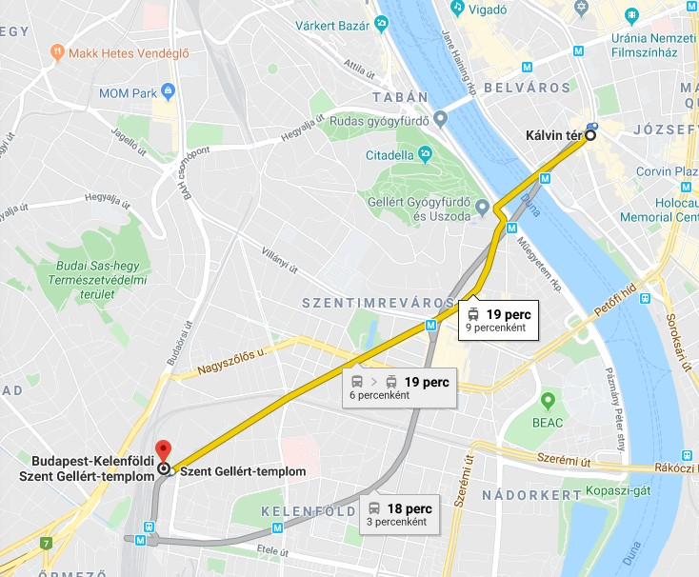

Tram:49

M4

#### 

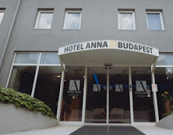

The Conference Venue:

[**Hotel Anna Budapest**](https://annahotel-budapest.hu/)

**Address**: Budapest, Kelenföldi út 1-13.

#### Accommodation:

Participants are responsible for booking their accommodation in Budapest.

#### Hotel information – The following hotels are in the nearby of conference location:

* [Hotel Anna Budapest](https://annahotel-budapest.hu/), H-1115 Budapest, Kelenföldi út 1-13

Reservation code: MELCOR2020 (limited number of rooms.

Please book early up to March 20.

* Danubius Hotel Flamenco, H-1113 Budapest, Tas vezér u. 3-7. tram/walking - 15 min
* Danubius Hotel Gellért, H-1114 Budapest, Szent Gellért tér 2. tram - 15 min

#### Currency exchange:

At the airport there are several ATMs’ outside international arrivals.

Hungarian national monetary unit is **Hungarian Forint (HUF) (1 EUR is approx. 340 HUF)**.

#### General information:

|  |  |
| --- | --- |
| Time zone: | GMT + 1:00 hour |
| Daily mean temperature: | Average High / Low Temperature 20 / 7 °C (May) |
| Currency: | Hungarian Forint (HUF) |
| Electricity supply: | 220 V AC, 50 Hz |
| Water: | Tap water is drinkable throughout the country |
| Internet/wi-fi: | Wi-fi access will be provided free of charge in the meeting room for all participants. |

**Language:**

All presentations and discussions will be in English.

**Meeting organization**

Dr. Gábor L. Horváth **NUBIKI**

Tel: +36 1 392 2222 # 2109 or +36 30 497 8410 www.nubiki.hu

Email: horvatlg@nubiki.hu nubiki@nubiki.hu