Developing characterization strategies for photocatalytic oxynitrides: a SrTaO_{x}N_{y} case study
Zahra Pourmand Tehrani,†‡ Christof W. Schneider,‡ Daniele Pergolesi,‡ Thomas Lippert†‡§
†Laboratory of Inorganic Chemistry, Department of Chemistry and Applied Biosciences, ETH Zürich, Vladimir Prelog Weg 1, CH-8093 Zürich, Switzerland
‡ Laboratory for Multiscale Materials Experiments, Paul Scherrer Institute, 5232 Villigen PSI, Switzerland
§ International Institute for Carbon-Neutral Energy Research (I2CNER), Kyushu University, 744 Motooka 819-0395 Fukuoka, Japan

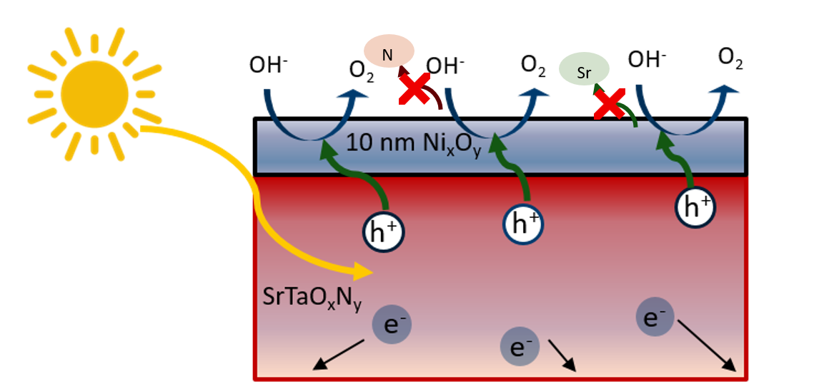
Oxynitrides are a class of semiconductors absorbing light in the visible range (380-700 nm). The size of the bandgap and the energy position of the band edges make oxynitrides promising candidates for visible-light-driven water splitting, with their performances enhanced by co-catalysts ¹. Probing the physiochemical evolution of a thin film ex-situ and under operation conditions provides insights into the physical and chemical processes occurring in the material.

Thin films possess relatively wide, well-defined and atomically flat surfaces, representing ideal model systems for the investigation of the semiconductor surface. Using this approach, we are exploring the origin for the enhanced charge extraction in a model oxynitride system, SrTaO_{x}N_{y}, with nickel-based (NiO_{x}) co-catalysts. NiO_{x} is among the most efficient metal-free co-catalysts for the oxygen evolution reaction (OER), suppressing the recombination of photo-generated electrons and holes³. Here, the OER is the bottleneck of the overall water splitting process and an improved understanding of OER mechanisms for oxynitride thin films is required.
Using ex-situ characterization techniques such as Neutron Reflectometry and Transmission Electron Microscopy, it is possible to identify material loss and modification in SrTaO_{x}N_{y} as a result of photo-electrochemical reactions. We identified the [011] lattice plane as a more favorable orientation compared to [001], with a significant performance enhancement upon NiO_{x} deposition. Operando shallow angle X-ray absorption spectroscopy measurements are performed on SrTaO_{x}N_{y} with and without co-catalyst during photo-electrochemical solar water splitting with a custom designed photoelectrochemical cell. Using the outlined approach, we aim to answer the open question regarding the driving force behind the observed detrimental surface modifications, the synergistic effects the co-catalyst has, and the role each cation plays. Addressing all these questions has large implications on the design and potential discovery of novel high-performance materials.
References
- Akkerman, et al. Genesis, Challenges and Opportunities for Colloidal Lead Halide Perovskite Nanocrystals. Nature Mater. 17, 394-405, doi:10.1038/s41563-018-0018-4 (2018).
- Raino, et al. Superfluorescence from Lead Halide Perovskite Quantum Dot Superlattices. Nature 563, 671-675, doi:10.1038/s41586-018-0683-0 (2018).

