

**The 16th Meeting of the  
„European MELCOR and MACCS User Group“**

**Organized by Brno University of Technology and TES**

**In support of the Cooperative Severe Accident Research Programme (CSARP)**

**will be held in**  
**Brno, Czech Republic**  
**7th – 11th April, 2025**





#### With special thanks to EMUG’s permanent stakeholders:

**United States Nuclear Regulatory Commission (US NRC)**

**Sandia National Laboratories (SNL)**

**Paul Scherrer Institute (PSI)**

********

**Announcement and Call for Presentations**

|  |  |
| --- | --- |
| Deadline for registration to the meeting  (including indication of presentation(s) title(s) and duration, technical visit confirmation) | **28th March 2025** |
| Presentation(s) in PowerPoint or in PDF format up to | **1th April 2025** |

On-line information is available at

https://www.psi.ch/emug/

# ORGANIZATION AND HOST

The 16th Meeting of the European MELCOR and MACCS User Group will be held at the rectorate of Brno University of Technology, Antonínská 548/1, 602 00 Brno, Conference room (ground floor), on 7th to 11th April 2025.

* The meeting will start on Monday 07th April. **Preliminarily**, the first two days will be devoted to MELCOR technical workshop presentations (SNL and NRC)
* The third and fourth days will be available for MELCOR user presentations and topical sesions.
* The 10th April (after Lunch) will be a technical visit to a full scale NPP simulator at the NPP Dukovany site. **There is a limited number of participants. Maximum 30 people (please declare if you want to participate in the visit during the registration,** **the order of application will be decisive).**

Final details and a final draft agenda will be sent to registered participants shortly before the meeting.

# BACKGROUND OF THE MEETING

The MELCOR and MACCS severe accident and consequence codes have been developed by Sandia National Laboratories (SNL) for the U.S. Nuclear Regulatory Commission (NRC) in the USA, and are provided to various European organizations through bilateral agreements under the ‘Cooperative Severe Accident Research Program’ “CSARP” between US-NRC and the European organizations. The codes have been used for many reactor safety applications by these organizations. Some of these organizations also continuously assessing the codes with data available from Severe Accident Research programs. A few organizations have also developed models for certain critical issues, which appear in local versions of MELCOR for testing and with the goal of implementation in future releases from SNL.

The main interests in establishing the user group are to foster experience and information exchange among European organizations through organized annual meetings and to establish common needs on further model and correctional development of MELCOR and MACCS. The first meeting of the EMUG hosted by PSI was held in December 2008. PSI is acting as coordinator of the group.

## AIMS OF EUROPEAN MELCOR and MACCS USER GROUP

* To provide a forum for the presentation and discussion of the experience gained by:
  + MELCOR assessment using integral and separate-effect tests leading to presentation of performance of models and related issues, including sensitivity to selected model parameters and model uncertainties;
  + Model development efforts;
  + Application of MELCOR for plant safety studies, including Level 2 PSA, which demonstrates strengths and weaknesses of MELCOR models in reproducing the individual severe accident phenomena, and interactions between them occurring in the nuclear part and balance of plant systems, and the effect of operator actions on the accident progression through user input as introduced in the code input models;
  + Application of MACCS for accident consequence calculations including Level 3 PSA;
  + Use of codes with different compilers and operating systems.
* Prioritization of user error correction and model development needs, to be transmitted to the code developers and the US NRC.
* To minimize the efforts required to obtain an adequate knowledge of optimum use of MELCOR and MACCS, through sharing of experience.
* To support the gaining of MELCOR and MACCS knowledge and experience, particularly concerning the younger and less experienced users.

# SCOPE, CONTENT AND OUTLINE OF THE MEETING

One day of the meeting will be devoted to MACCS code and two days to MELCOR code. Both parts of the meeting (MELCOR and MACCS) are divided into two sections:

## NRC and SNL Presentations

About one day will be devoted to presentations from NRC and SNL / MACCS developers, and about one day will be devoted to presentations from NRC and SNL / MELCOR developers. Each of the following four topics could be given by one presentation for each code:

* NRC MELCOR / MACCS Activities
  + Code applications
  + Code perspectives, possibility of distribution to international partners, status and future areas of CSARP program
  + New considerations of code development
* MELCOR / MACCS input
  + New features of input conversion
  + New input capabilities in MELCOR 2.2
* Current MELCOR / MACCS development thrust areas
  + Quality assurance
    - Code assessment work and regression testing
    - Code distribution and issue management
  + New MELCOR / MACCS Models – discussion of new modelling and experience using new models
  + Current code development
* Applications
  + MELCOR / MACCS best practices
  + Guidance for plant applications

## User Presentations

About one day will be devoted to presentations from all European organizations for MELCOR and MACCS. For those who would like to present their experience in plant applications of MELCOR 1.8.6, MELCOR 2.2 and MACCS, the organizers of the meeting express their wish to see presentations not only on specific aspects of the plant applications evaluating safety aspects of the plants in interest but also the experience in the use of the models, input parameters, nodalization aspects which have a certain bearing on the performance of the code, as well as the quality of the code estimates.

Presentations will be possibly grouped into the following 4 sessions for MELCOR:

* Group 1: User experience with nodalization regarding simulation of different issues with preference to focus on RCS, core and RN inventory and release modelling;
* Group 2: Modelling features (early and late phase core degradation, corium pool formation, lower head behaviour, RN release, SFP, etc), new modelling efforts and nuclear fusion application;
* Group 3: Model development and assessment, integral assessment, sensitivity studies, code to code comparison (different MELCOR versions or comparison to other codes), plant applications (link to uncertainty analysis, PSA Level 2 and PSA Level 3, etc.);
* Group 4: Post-processing of results (including the possibility of sharing of tools developed by users), run time performance.

A special session is planned **(to be confirmed)** for European MACCS users to exchange knowledge with colleagues from other institutes.

Discussion of all participants

* Feedback from the participants – user suggestions to further code development (it could be included in presentations) and organizational aspects: next meeting(s)

# PRACTICAL ARRANGEMENTS

#### Participants:

Participation at the meeting is open to experts of the European organizations actively using the MELCOR or MACCS code in any of its versions. EMUG meeting is by invitation only open to European CSARP members. Also note that in order to attend either of the code user workshops, you need to be an authorized user of that specific computer code. The success of the meeting is very much dependent on the active participation of those present, especially by presentations on their own experience with the code.

#### Registration:

All the participants should fill in the **Meeting Registration Form** that is attached to this document, including the title(s) of presentation(s), and send it **before the 28th March 2025** to:

E-mail:[**Peter.Mician@vutbr.cz**](mailto:Peter.Mician@vutbr.cz)

**And**

E-mail:[**mateusz.malicki@psi.ch**](mailto:mateusz.malicki@psi.ch)

A registration fee will not be required. The participants bear the cost of travel and accommodation.

The organizers will graciously host coffee breaks with snacks. For dining options, various restaurants are located just outside the building.

#### Language:

All presentations and discussions will be in English.

#### Presentations:

Presentations (in MS power point or Acrobat pdf format), should be sent to [Peter.Mician@vutbr.cz](mailto:Peter.Mician@vutbr.cz) and [mateusz.malicki@psi.ch](mailto:mateusz.malicki@psi.ch), at the latest on 1st April. The presentations will be uploaded to the EMUG group website after the meeting with the permission of the participants.

**NOTE: If you do not want to or cannot publish your presentation online, you are obliged to mention it clearly during your registration.**

**Passport and Visa:**

For non-EU participants: A valid passport is required to enter the Czech Republic. Please ensure that your passport is valid for the duration of your stay.

Visa Requirements: Participants from countries that require a Czech entry visa must apply for one in advance. It is advisable to check with the Czech Embassy or Consular Office that covers your country for specific visa requirements and application procedures.

Assistance with Visa Application: If you require a visa to enter the Czech Republic, please get in touch with us for assistance. We will provide an official invitation letter for the visa application process at the Czech Embassy if required.

**Arriving in Brno:**

**By plane**

**Vaclav Havel airport in Prague** – the main international airport in the Czech Republic. It provides many international flights. It is suitable to choose this airport if you want to spend some time in Prague. Most of the connections from Prague airport to Brno is indirect, you have to transfer at Prague stations. You can reach Brno from this airport by:

* Flixbus ([www.flixbus.cz](https://www.flixbus.cz)) - the most simple way to reach Brno by bus.
* Regiojet bus (<https://regiojet.cz/>) - an alternative to the Flixbus bus. There is one transfer at the Praha-Florenc station.
* Regiojet train (<https://regiojet.cz/>) – the Regiojet operates the trains between Prague and Brno. But you need to use the public transportation system for transfer to the Main train station located in the Prague city center.
* Czech railways ([www.cd.cz](https://www.cd.cz)) – the Czech railways connect Prague and Brno as well as the Regiojet. The same conditions apply.
* The public transportation system in Prague ([www.dpp.cz](https://www.dpp.cz)) – It can be used to reach the Main train station in the Prague city center.
* Taxis or Car Rentals: Available at the airport.

**Vienna Airport (Austria)** - this airport provides many international flight connections and it is preferred over the Vaclav Havel airport in Prague due to the closer distance (150 km) thus shorter time on the way and direct connection. You can reach Brno by:

* Regiojet bus/train (<https://regiojet.cz/>) - the most simple way to reach Brno. It is strongly advised to book the bus as soon as the airplain ticket is bought since the tickets are sold out weeks in advance.
* Flixbus ([www.flixbus.cz](https://www.flixbus.cz)) - an alternative to the Regiojet bus.
* Gepard express ([www.gepard.com/en](https://www.gepard.com/en)) - A small company providing transport by mini-vans. The fastest way to reach Brno.
* Austrian and Czech Railways – find the connections at [www.cd.cz/en/spojeni-a-jizdenka/](http://www.cd.cz/en/spojeni-a-jizdenka/)
* Taxis or Car Rentals: Available at the airport.

**Brno Airport** - mainly serves low-cost airlines and is about 10 km from the city center. Reach the city by:

* Public transportation system in Brno ([www.dpmb.cz/en](https://www.dpmb.cz/en)).
* Taxis or Car Rentals: Available at the airport.

**By train**

Brno is connected by train with other major cities in the Czech Republic and Europe. The Main train station is located in the south of the city center.

**By bus**

The Regiojet (<https://regiojet.cz/>), Flixbus ([www.flixbus.cz](https://www.flixbus.cz)) and other various companies provide the bus connection to major european cities. Buses usually terminate at AN Grand Hotel Station or at bus terminal Zvonařka.

**By car**

You can reach Brno by car easily but you have to count on some traffic jams on highway. For parking in Brno, it is recommended to use the hotel garage. Long term parking in the street is possible, but fees are higher ([www.parkovanivbrne.cz/en](https://www.parkovanivbrne.cz/en)). Another recommended option is to use the parking facilities close to the rectorate:

* JD parking - [www.jdparking.cz](https://www.jdparking.cz)
* Mr. Parkit - [www.mrparkit.com/en](https://www.mrparkit.com/en)

#### Local transport in Brno:

Once in Brno, you can use DPMB services (buses, trams, and some trains) to get around. DPMB info on DPMB web site [www.dpmb.cz/en.](https://www.dpmb.cz/en)

DPMB is the company that manages public transportation in Brno. They offer various ticket options to suit different travel needs. Here are some details about the ticket types and prices (please note that prices may change, so it's always a good idea to check the latest information on the official DPMB website):

**1. Single Ticket 15 minutes:**

* Price: 20 CZK
* Validity: 15 minutes from validation, allowing unlimited transfers between buses and trams within the timeframe.
* Note: for short travels (suitable for transporting in the city center)

**2. Single Ticket 60 minutes:**

* Price: 25 CZK
* Validity: 60 minutes from validation, allowing unlimited transfers between buses and trams within the timeframe.
* Note: for almost all travels within Brno

**3. Brno 24H (Daily Ticket):**

* Price: 90 CZK
* Validity: 24 hours from validation, offering unlimited travel on buses, trams, and urban railways within Brno.

**4. Brno 120H (5-Day Ticket):**

* Price: 250 CZK
* Validity: 120 hours from validation, with the same conditions as the daily ticket.

**Important Points to Note:**

* Tickets must be validated at the start of your first trip and kept until the end of your journey. If you use paper ticket, you should validate at the bus or tram in validation machine.
* Tickets are valid across the entire public transportation network in Brno (buses, trams, and some railway lines).
* You can purchase tickets at stations, newsstands, and tobacco shops. Buses and trams are equipped with machines for paying by card (contacless) The credit card compatibility is not ensured, but the way of Beep and Go is very commonly used. More information here: <https://pipniajed.cz/en.html>
* Be aware of ticket inspectors and always have your validated ticket with you while traveling.

Taxis are available in Brno but ensure to use official taxi services. Bolt and Uber are also available.

**How to arrive to Rectorate**

The rectorate building is in walking distance from the city center. Arriving at rectorate can be conveniently done using public transportation from any point in the city.

The rectorate building:

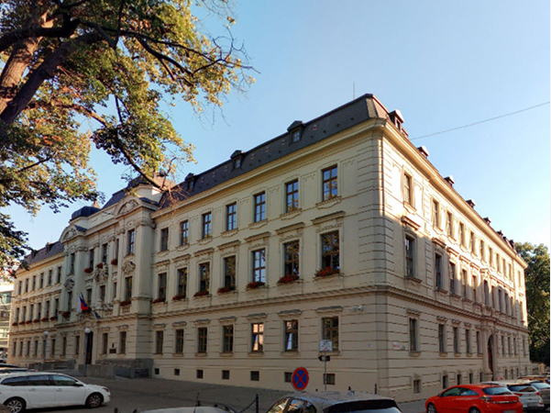

The nearest bus stop is “Smetanova” (buses no. 32, 34, 36, 38, and 39):

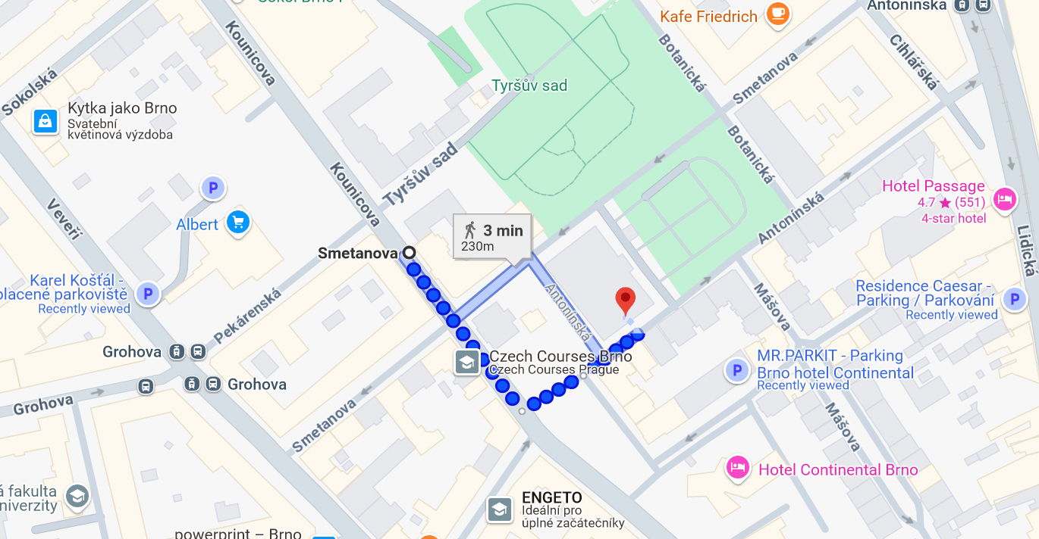

The nearest tram stops are “Grohova” (trams no. 3 and 12) and “Antoninska” (trams no. 1 and 6):

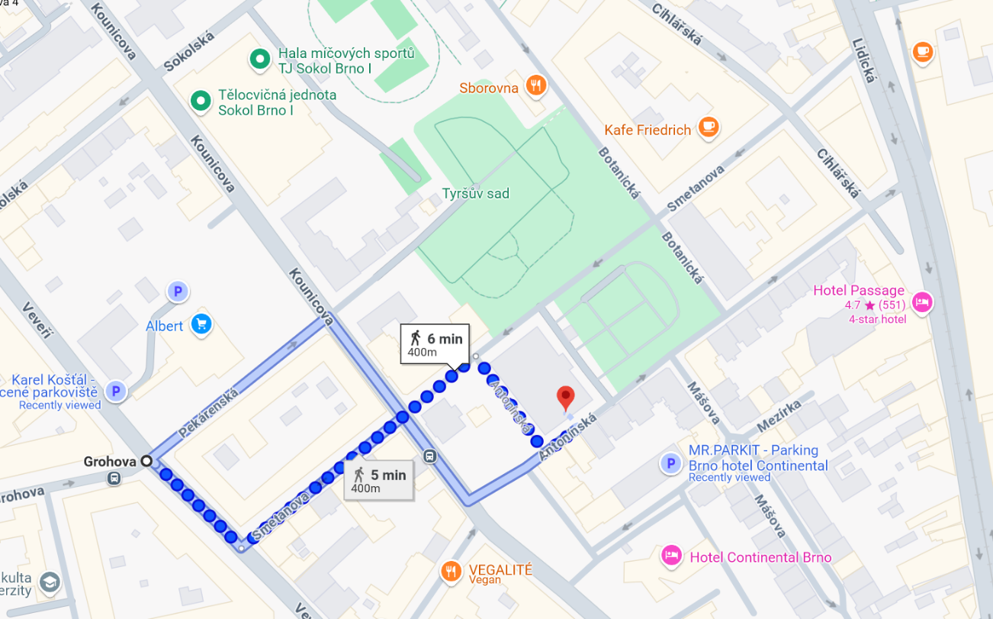

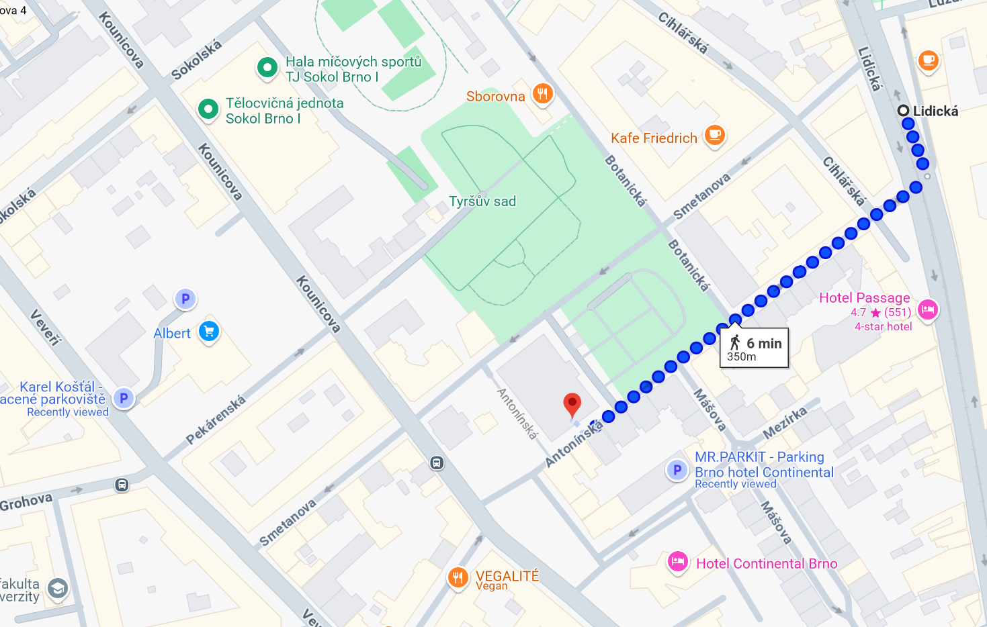

All the above mentioned buses depart from the “Česká” street. The trams connect various parts of the city. Depending on your starting point, you can get on the bus or tram from different locations in Brno. Use Google Maps to find the best bus route from your location.

**Accomodation**

There are several hotels in Brno offering different levels and qualities of service. Please choose according to your preference.

Here are two options of good quality and close to the event venue:

* Hotel Passage (<https://www.hotelpassage.eu/>) (5 minutes of walking)
* Hotel Continental (<https://www.continentalbrno.cz/en>). (2 minutes of walking)

**The Conference Venue:**

The rectorate of the Brno University of Technology

Address: Antonínská 548/1, 602 00 Brno

The meeting will take place at conference room at ground floor.

**General information:**

|  |  |
| --- | --- |
| Time zone: | GMT + 1:00 hour |
| Weather in Brno in April | Average temperatures range from a low of around 4°C (40°F) in the early mornings and nights to a high of around 15°C (59°F) during the day. |
| Currency and payment | Czech crown (koruna) CZK, exchange rate 1 EUR = around 25 CZK. Paying by card is possible in most pubs and shops. |
| Electricity supply | 230 V, 50 Hz  In the Czech Republic, the primary type of plug socket is Type E (common in France, Belgium, Poland, and other European countries). Additionally, Type F sockets (known as "Schuko," used widely in Germany and across Europe) are also commonly compatible. |
| Water | Tap water is drinkable throughout the country |

**Meeting organization**

Peter Mician

Brno University of Technology

Email: [Peter.Mician@vutbr.cz](mailto:Peter.Mician@vutbr.cz) www.vut.cz

Dr. Stepan Foral

TES s.r.o.

Email: [foral@tes.eu](mailto:foral@tes.eu) www.tes.eu

Dr. Mateusz Malicki PSI

Paul Scherrer Institut

Email: [mateusz.malicki@psi.ch](mailto:mateusz.malicki@psi.ch) [www.psi.ch](http://www.psi.ch)