Form A_03

Description of the Research Proposal for the application

Proposal ID-No.:

Before getting started with the research proposal, please read Form A_05, “Guidelines for applicants”. The research proposal is a description of your research project. It is important to be familiar with the selection criteria that will form the basis for reviewers to evaluate the scientific merit of your research proposal.

Format/fonts to use:
Please use the following layout for the preparation of your research proposal, boxes should be expanded as needed, maximum length of the research proposal is five (5) A4 pages. Font type Verdana, font size 10.

Title:

Abstract: Write a short abstract that summarizes the goals and anticipated outcomes (250 words; 0.5 pages).

Project Description: Develop a work plan in which research objectives, milestones and tasks, suitable experimental approaches are described. Include as well a feasibility analysis (2 pages).

References: Include minimum 7 (and max. 10) literature citations, which are considered as key literature/references for your research, project (0.5 pages).

PI’s/Supervisor’s Addendum: Provide a short description how you will support the applicant and which resources will be attributed to the project. (0.5 pages).

Project Management table: Prepare an overview table that schedules the milestones and main tasks along a timeline of 24 months. It is important to identify at least 3 milestones and 2 tasks per milestone. The table below has 6 project time periods (e.g., 0-4 months is one such interval) and your project should be presented with a similar time planning, not more than 6 and not less than 4-time intervals (i.e., 0-6, 7-12, 13-18 and 19-24 months).

Use as well color coding to show that the progression of the science over time (that is, Milestone 1 and Milestone 3 is not reached at the same time and that achievement of Milestone 3 is dependent on reaching Milestone 1). (0.5 pages)

See an example here below (font size Verdana 10).

Goal of project:
 | Project month
 | 0-4 | 5-8 | 9-12 | 13-16 | 17-20 | 21-24
Milestone 1

Task 1
Task 2 (- Task X)
Milestone 2

Task 1
Task 2 (- Task X)
Milestone 3
(- Milestone X)

Task 1
Task 2 (- Task X)

One pager Project Overview: Prepare a one-page document (could be a PowerPoint slide) with sections: Aim, Outcome and Future Perspective to summarize your project. Include as well a picture, diagram, photo, etc. that could serve as visual representation of your research project proposal. Maximum 60 words are allowed for the section’s areas below “Name” and “Title”. (1 page)

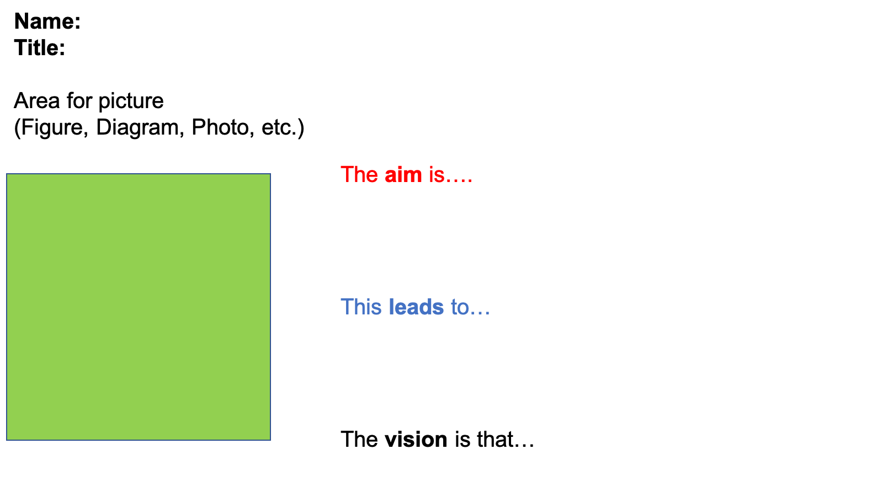

https://www.psi.ch/psi-fellow/list-of-principle-investigators-and-themes

